[Answer all Three (03) questions. Use proper references of your Information, thought and ideas. DO NOT COPY FROM INTERNET/ANY BOOK. All questions carry equal marks. ***Total Marks for this assignment is 30***]

1. ***How dark web differ from deep web? How many tabs can be opened within a browser? 5000, 10000, 100000 or more? Write a batch file for windows system and show the output. [Maximum 300 words]***

**Answer:**

**Dark web:** Dark web is not indexed by search engines because it wants to ensure anonymity. Dark web consists of websites which is used by public internet. One can enjoy dark web by using specific software and tools for access. It is basically stolen data.

**Deep web**: Deep web is ninety percent of the World Wide Web. Various types of company, web developers, and websites tell Google not to search or categorize this information, so when one search in internet this does not come up. Deep web can be accessed by typing any direct web address.

**Difference between dark web and deep web:**

* Deep web, the portion of the Internet that is hidden from conventional search engines, as by encryption, the aggregate of unindexed websites and Dark web is the portion of the Internet that is intentionally hidden from search engines, uses masked IP addresses, and is accessible only with a special web browser.

|  |  |
| --- | --- |
| Deep Web | Dark Web |
| The deep web is vast and accounts for 90 percent of the Internet, | The dark web likely only accounts for about .01 percent. |
| Deep web requires password, encryption, or specialty software. | Dark web requires Tor projects or similar to view. |
| All unindexed web pages. | Subset of unindexed webpage’s inside the deep web. |
| Massive, Likely 4-5x larger than the surfer web. | A subset of the deep web, but immeasurable in size |
| Usually used for legit purposes that requires anonymity. | Sometimes used for illegal services. |
| Users are whistleblowers, journalists etc. | Users are hackers, sellers, buyers of illegal merchandise. |

How many tabs can be opened in any browser: By using XTabs, one can set the maximum number of tabs in window. The extension installs a button to the browsers URL bar. The default number is 20.But the number of tabs can be opened which also depend on the ram or the loading capacity of pc.

* In one sites more than 10000 tabs can be opened which is known as DDoS attack.
* How many tabs can open its basically depends on the pc ram and if its capacity is 1Tb then 1000 tabs can be opened. 1000 tabs don’t have any effects on chrome like browsers.
* Above 1000 tabs systems getting slower so if we reach like 2000 tabs then it can be stopped and speed dropped and windows will be paused.
* So if we go beyond like 5000 tabs the chrome will crash and terminate the speed.

So we can say that the number of tabs we can open in any browser it only depends on the RAM and the processor capacity.

## The Batch file for windows system and output:

@echo off

Title: Assalamualaikum Sir.

::See the title at the top

echo Hello! Im Khadizatul Kubra.

@echo off

echo Congratulations! Your batch file executed successfully. Pause



1. Write a program to calculate the page rank (PR) of the following. 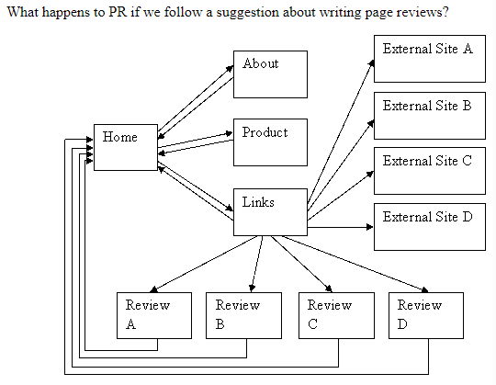

**Answer:**

$soha = 0.85;  
$a = $b = $c = $d = $e = $f = $g = $h = 0;  
$iterate = 40; # loop; 40; times;  
  
# forward; links;  
# a; -;> b;,c,d-; 3; outgoing; links;-; home;  
# b; -;> a;    -; 1; outgoing; link;    -; about;  
# c; -;> a;    -; 1; outgoing; link;    -; products;  
# d; -;> a;,e,f,g,h,i,j,k,l-; 9; outgoing; links;  
# e;,f,g,h    -; nothing;     -; external; sites;  
# i; -;> a;    -; 1; link;     -; review; of; e;  
# j; -;> a;    -; 1; link;     -; review; of; f;  
# k; -;> a;    -; 1; link;     -; review; of; g;  
# l; -;> a;    -; 1; link;     -; review; of; h;

# "backward" links; (what's pointing; to; me;?)  
# a; <= b;,c,d/9,i,j,k,l  
# b;,c,d <= a;/3  
# e;,f,g,h,i,j,k,l <= d;/9  
while ($iterate--) {

printf;("a: %.5f b;: %.5f c;: %.5f d;: %.5f e;=f=g=h: %.5f i;=j=k=l: %.5f\n",}

**Output:**

a: 2.43972 b: 0.84125 c: 0.84125 d: 0.84125 e=f=g=h: 0.22945 i=j=k=l: 0.22945

Average PR = 0.566

1. ***Compare the scenario of online delivery service of Bangladesh vs worldwide in this pandemic situation. What is your opinion to improve this scenario in this current pandemic situation for Bangladesh? Justify your suggestion with proper information and infrastructure that currently Bangladesh may use of it.***

***[Use proper citation of your information and make your own graph (if any) by collected data from the web.] [Maximum 1000 words]***

**Answer:**

Corona Virus first started in China in December. It has expanded nearly every corner of the globe. After 3 months later this virus came to our country. After 1 month of lockdown the agricultural system and day-to-day necessary products production got affected. People couldn’t go outside due to pandemic and couldn’t buy daily necessities. So, here comes the online delivery system. Not only food but also other things like dress, electric products, cosmetics, medicines etc are also delivered by some online companies. E-commerce sites of the worldwide also feels corona virus pinch. The global financial and economic growth suddenly falls apart due to corona virus.

World’s online delivery companies are UberEats, Grubhub, Just Eat, Deliveroo, Delivery.com, OLO, FedEx, DHL etc.

In Bangladesh Sheba.xyz, Daraz, perfee, ChalDaal, Shawpno, AjkerDeal.com, Rokomari.com, Bikroy.com, ClickBD etc are popular online courier and delivery companies.

## World delivery companies scenario we can see:

Many world’s leading food delivery companies are collaborating with AI technology companies to deliver food with robots, drones and self-driving cars. They use GPS and camera to determine the optimum route to ensure quick delivery of food to the customers. The use of Big Data is also gaining popularity among takeaway food delivery service providers. By collecting and analyzing information such as purchasing history, road traffic, market trends, and online reviews, the food delivery companies will be able to precisely estimate customer’s food preferences and delivery time.

* **AMAZON**:
* Due to pandemic Amazon and other companies decided to launch side-walking Robot and drone.
* Amazon also warned shipping times are slower due to the high demand for online shopping. .
* Services like Prime Now and the Amazon Fresh grocery delivery service reported limited availability for several days.
* Working to avoid disruptions in the supply chain, while some factories in China and elsewhere remain offline.
* **McDonald’s** :
* Some of the world’s biggest food chains using the apps, such as McDonald’s and Wagamama, have closed in the United Kingdom for the time being.
* **UPS and FedEx**:
* UPS and FedEx are also moving toward electric vehicles, including cargo e-bikes.
* **Uber**:
* Uber is pledging 10million free rides and deliveries of food for frontline healthcare workers, seniors, and people.
* Providing free meals on Uber Eats to first responders and healthcare workers in US and Canada.
* Waived the Delivery Fee for the more than 100,000 independent restaurants across US and Canada on Uber Eats.
* Uber Freight is donating the delivery of essential goods like food, face masks, and hospital beds to healthcare facilities and food banks across US and Canada.
* Uber Health is providing free transportation for frontline healthcare workers, helping them get to and from patients’ homes.
* **Deliveroo**:

-Deliverro has issued guidance on how their riders can stay safe and make food deliveries without touching restaurant packaging.

* **Burger King**:

-Burger King has also reopened some drive-through restaurants – [prompting long trafficqueues](https://www.bbc.co.uk/news/uk-england-52746790).

## Bangladesh’s Delivery Companies Scenario:

E-commerce sites in Bangladesh are experiencing a surge in online orders -- mainly for grocery items, over the counter medicines, and other daily essentials amid the ongoing corona virus pandemic.

However, due to the fear of getting infected by the deadly virus, most of them who deliver goods to the doors of consumers are not willing to work.

* **Uber eats** :
* Uber eats in Bangladesh shut down their business.
* **Pathao:**
* They have relaunched Pathao "Tong", an on-demand essentials delivery service, in response to the corona virus pandemic.
* Users can also order non-prescription and OTC medicine from Pathao "Pharma”.
* Taken the decision to enable contactless delivery and to ensure that the payment is done digitally.
* Delivery agents have been trained to stand at least three feet away from the door of a household they are delivering at.
* **HungryNaki :**
* Provides mask and other safety equipments to their delivery agents.
* **FoodPanda**:
* Partnered with Lifebuoy to give out Lifebuoy hand washes to all riders and restaurant partners to ensure regular hand washing is practiced both at work and at home.
* 20,000 free meals for first responders and healthcare workers as well.
* **DARAZ**:
* Took all possible steps to ensure stability in prices of medical supplies.
* Provided guidelines to ensure delivery personnel wearing gloves for safer cash handling at the time of delivery.
* **Shwapno**:
* Recruits 300 staff amid Covid-19 pandemic.
* Recruits third gender people as their delivery agents.
* Working Hand in hand with farmers to get fair price of the product.
* **ChalDal.com** :
* Chaldal.com only opens their online payment option. They’re not supporting cod(cash on delivery)
* They are paying them a 50 percent bonus on salaries.

How to improve the scenario of online delivery System due to pandemic in Bangladesh:

1. Proper hand sanitization andprotection: Companies should train and give delivery agents mask, gloves and other items for security of the delivery agents.
2. Price and Vat**:** The price and VAT should not be so high. Most companies taking high amount of Vat which is also another big issue for some customer.
3. Safe packaging and shipment: The packaging and the food bag must be disinfect and sanitize.
4. Leave delivery Instructions: After delivery leave instructions.
5. Over tip delivery agent**:** This is precarious, low-waged employment without benefits and such, and these are difficult financial times for many.
6. Fast Response and quick delivery: There should be an option as emergency medicine and quick delivery.
7. Social Media Advertising: More online service companies should be advertising their services on social media.
8. Launch more fun product: A marketing campaigns with headlines that reference “staying busy,” can be a great way to help customers to find fun products to sell that they might not have thought of as a way to help fill the time.
9. Limiting purchasing Quantity: Consider limiting purchase quantities of items that will be in high demand so that everyone has a chance to get some.
10. Reconsider Discount strategy: Consider offering free or low cost digital products.
11. Gift Cards: Selling promotional gifts can give companies opportunities to build longer term relationships with customers.
12. Take device preferences into consideration: People are staying at home and they may use their PC a bit more than their mobile. Make sure to include this in your strategy and optimize budget allocation per device.
13. PHONE CODE: Use phone code rather than signature receiver form.
14. Flexibility in delivery: Do not focus on just one carrier, but look into alternative local carriers like bike couriers as an alternative.
15. Website Management: Make sure the website is running at optimum capacity and it is not overloaded and does not crash.
16. Collaboration with an offline retailer: Offline retailers are significantly struggling in these times. By working together you can both increase your sales and broaden your target.

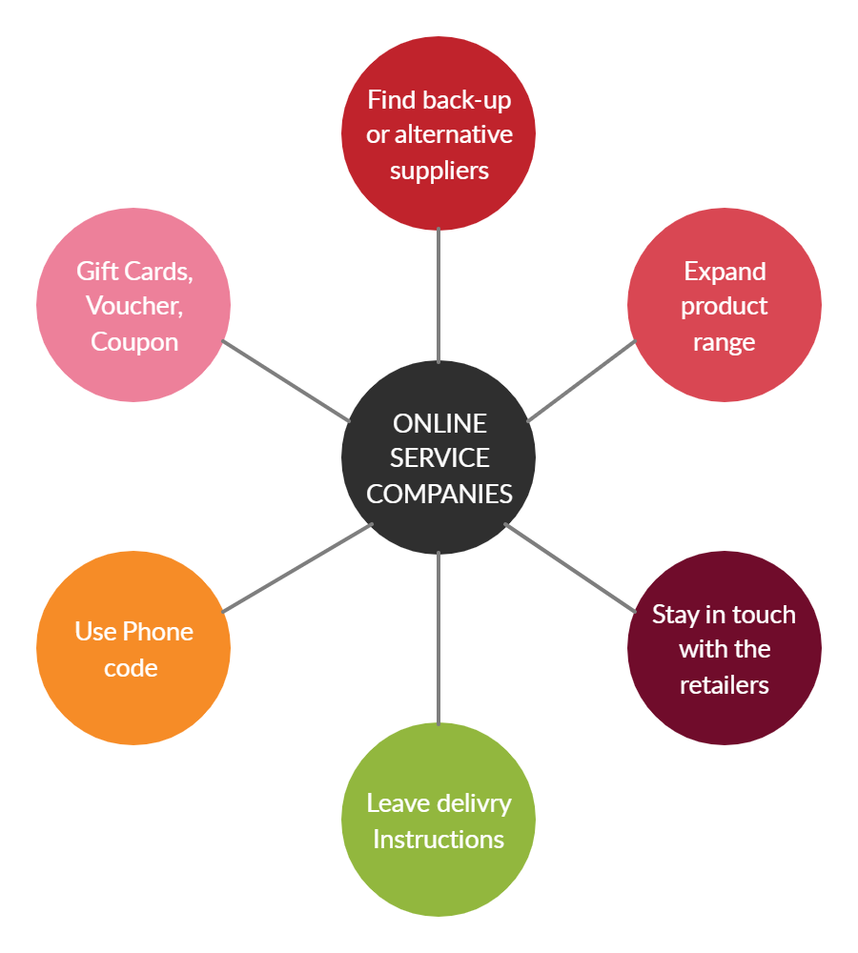

Figure: Flowchart of online delivery system

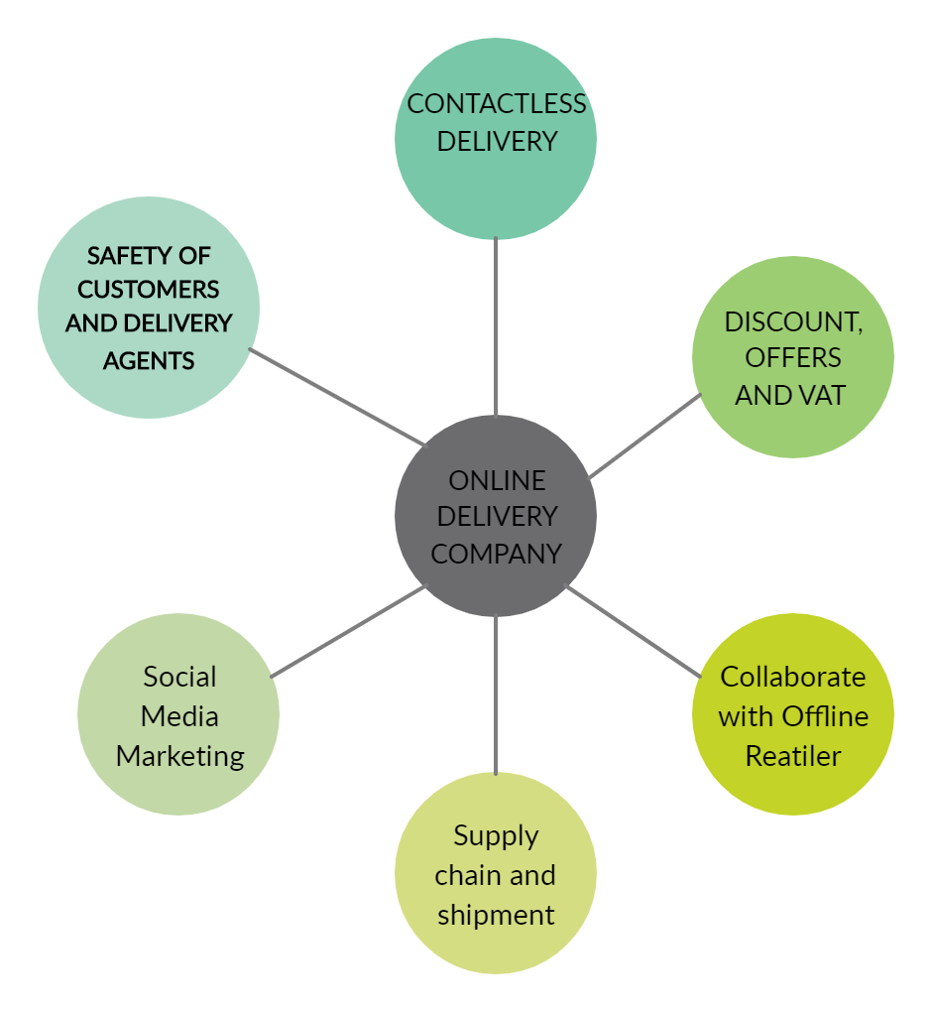

Figure: Flowchart of online delivery system

However, broadband connectivity may be a hurdle if we go deep into the country, where these companies want to cast their net. There will be challenges, too. It will be a cultural shift for consumers to become comfortable making online payments. Even physical infrastructure of roads for last-mile delivery is an issue, especially in our country.

Reference:

1. <https://www.quora.com/What-is-the-difference-between-the-deep-web-and-the-dark-web>
2. <https://econsultancy.com/stats-roundup-coronavirus-impact-on-marketing-ecommerce-advertising/>
3. <https://www.bigcommerce.com/blog/covid-19-ecommerce/>
4. <https://creately.com/> (for flowchart)